1. Check for prerequisites
   1. Python3.6 + installed
   2. Pip available
   3. Internet connection
   4. Have oci user account with API key access

1. A computer screen with text on it

   AI-generated content may be incorrect.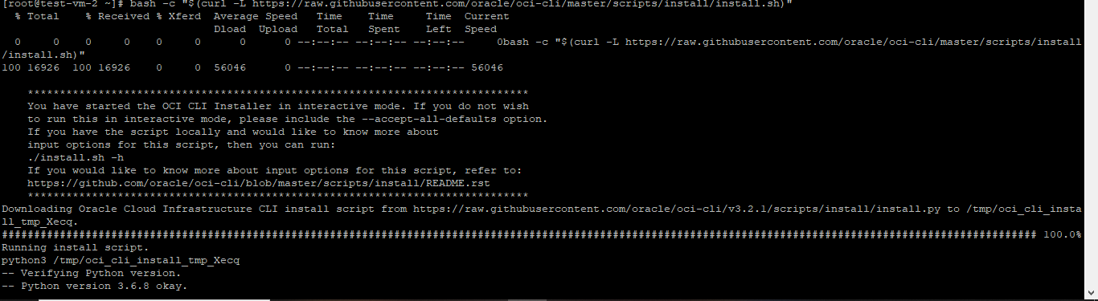Now install OCI CLI using [ bash -c "$(curl -L <https://raw.githubusercontent.com/oracle/oci-cli/master/scripts/install/install.sh>)" ]
2. Check if it is working (oci –version)
3. Setup OCI CLI (oci setup config)
   1. Here you have to mention your user OCID and tenancy OCID so keep your tenancy logged in
   2. A computer screen shot of text

      AI-generated content may be incorrect.A black screen with white text

      AI-generated content may be incorrect.Keep rest all by default
4. 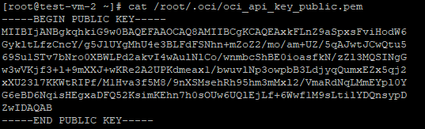Now cat the api public key using (cat /root/.oci/oci_api_key_public.pem)
5. Copy the whole key
6. Now go to the oci console > your user profile > tokens and keys > add api key > paste the copied key there and save it
7. 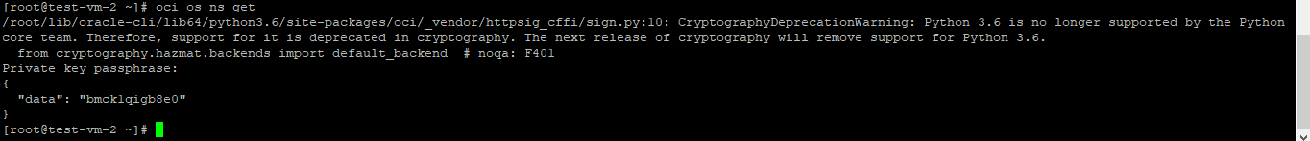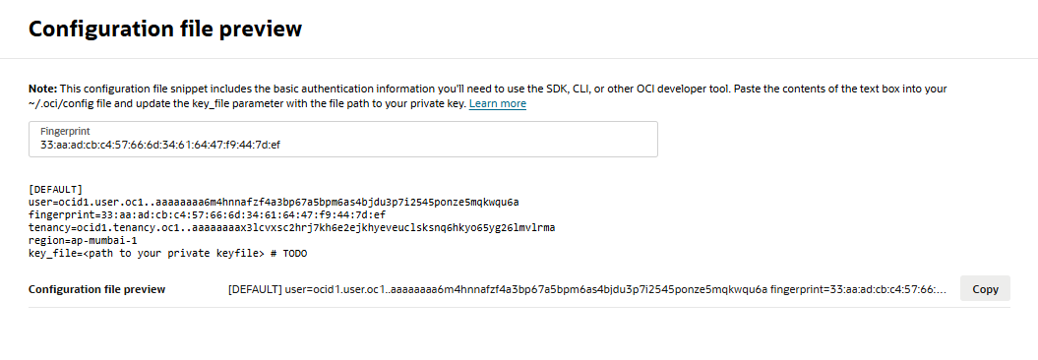Go back to the instance and run (oci os ns get) if it returns your object storage namespace, your cli is ready.